**LAB TEST – 1**

**SET - 1**

***Perform Find_S Algorithm***

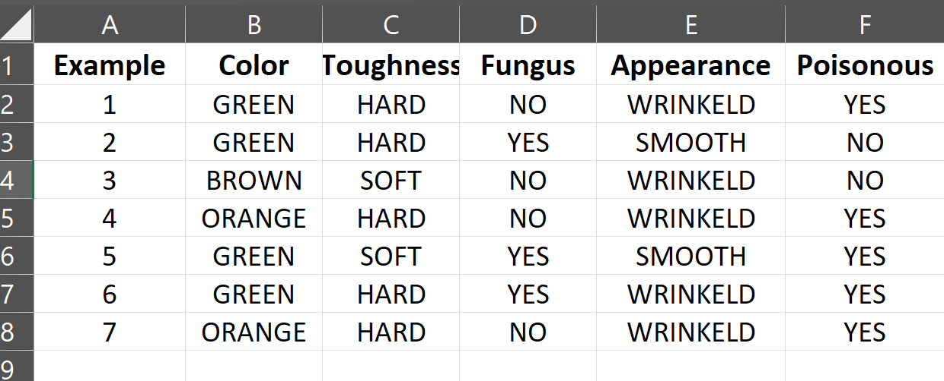

**1.Import and read the dataset**

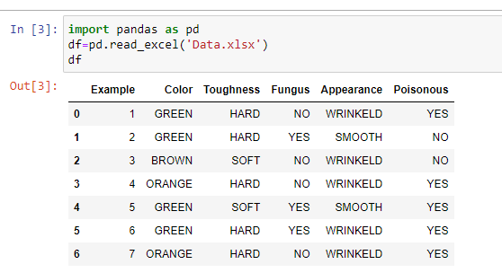

**2. Drop unnecessary columns**

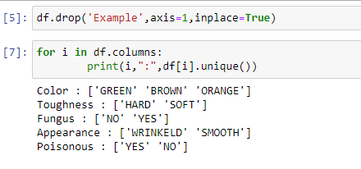

**3. Print unique values from the dataset**



**4. Set the target variable as ‘Poisonous’**

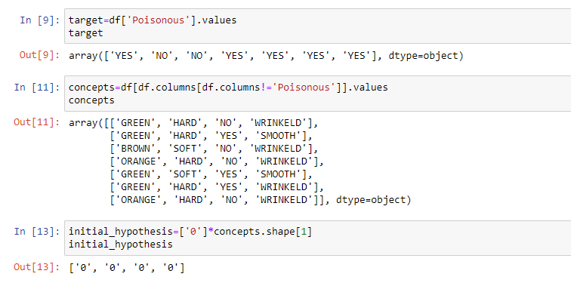

**5. Set all other columns as concepts (features)**



**6.** **Initialize the hypothesis as ‘0’**



**7. Implement the Find-S Algorithm for 'Poisonous' values**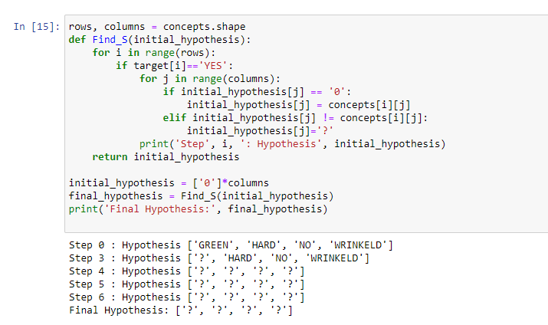

**7. Implement the Find-S Algorithm for 'Non-Poisonous' values.**

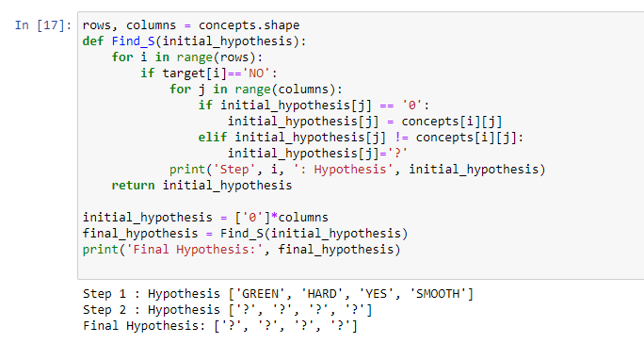

**SET - 2**

***Perform KNN classification using Diabetes.csv***

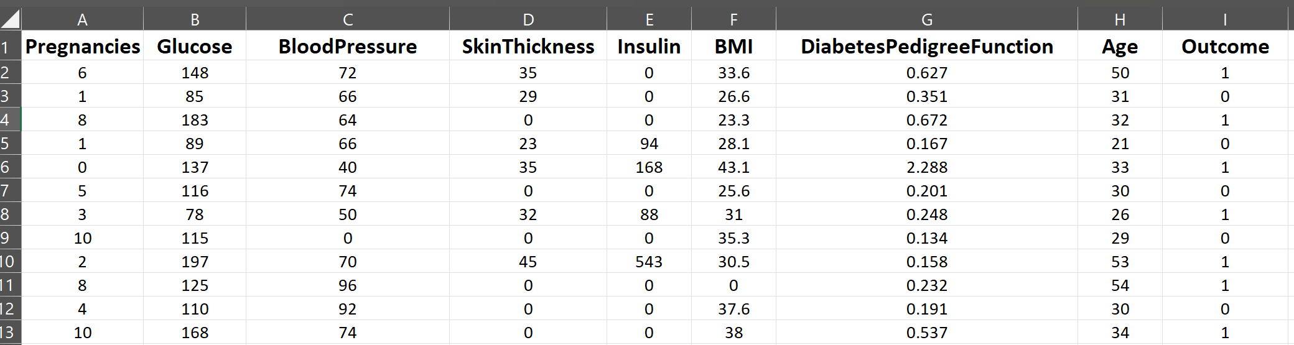

**1.Read the Diabetes CSV file and check for null values**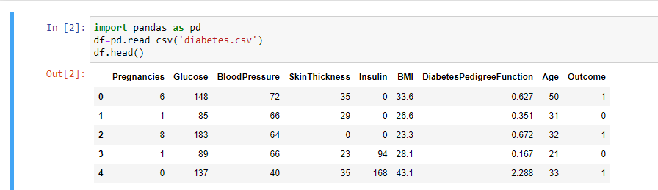

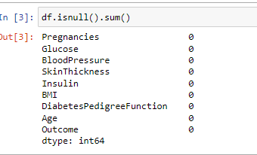

**2.Select features for training and set the target variable as Outcome**

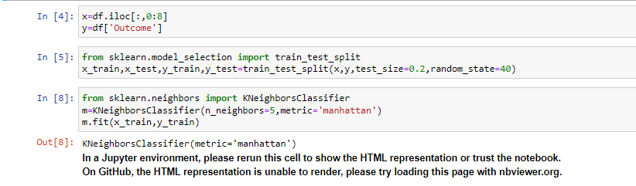

**3. Split data into 80% training and 20% testing using train_test_split**



**4 .Train the model with N=5,Manhattan metric and 20% test data**



**5. Make predictions on the test data using a trained K-Nearest Neighbors (KNN) classifier**

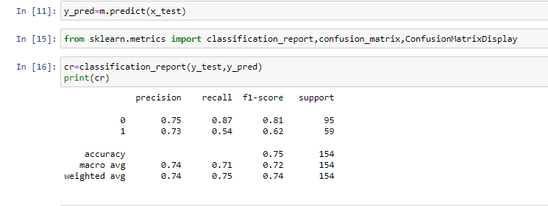

**6. Classification Report for Model Performance Evaluation**



**6. Display the confusion matrix for predicted and actual values**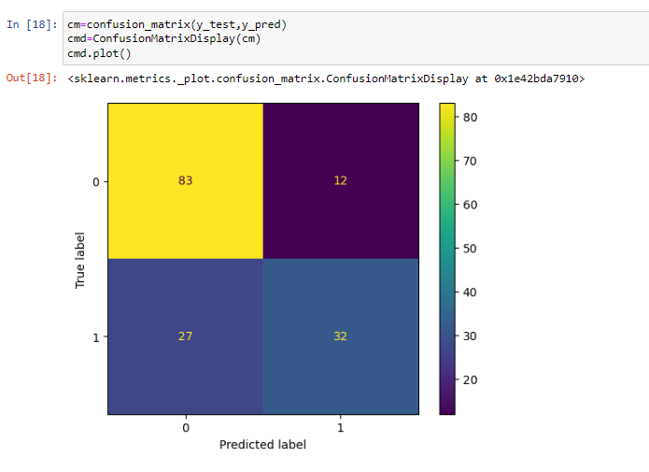

**SET - 3**

***Perform Linear Regression using advertising.csv***

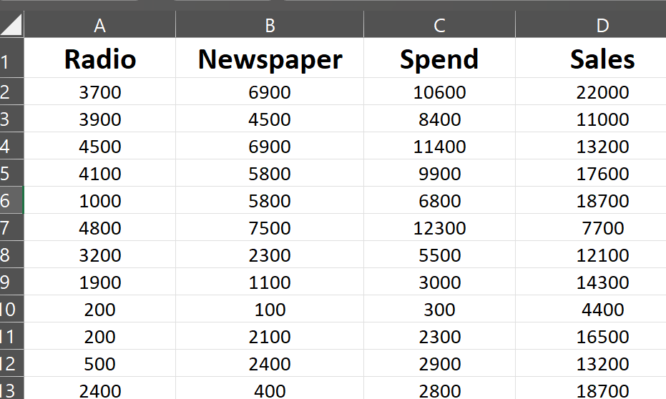

**1.Read the Advertising dataset**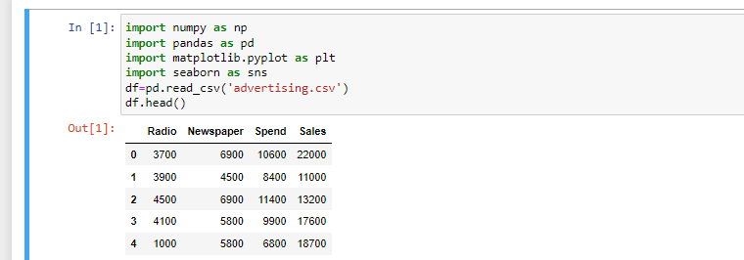

**2.Rename the columns Sales to ‘Total Sales’ and Spend to ‘Total Spend'**

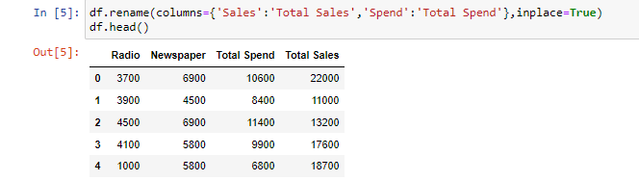

**3.Display a Scatter Plot for Total Sales and Total Spend**

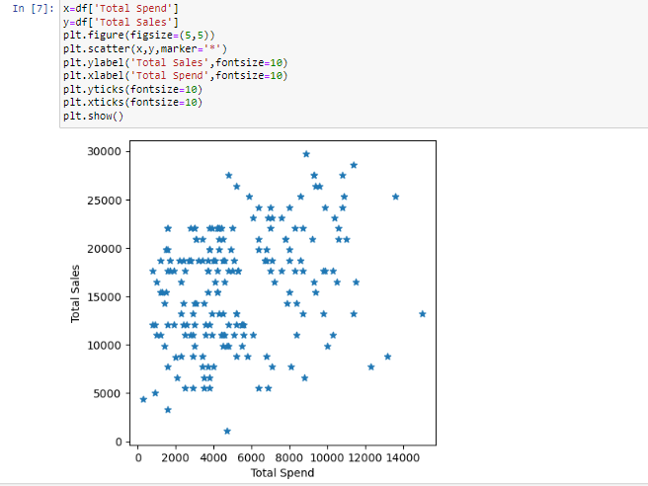

**4. Find the slope and intercept of the regression line**

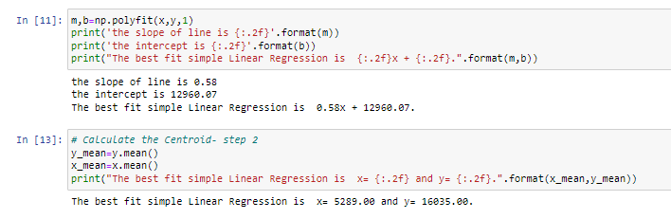

**5. Calculate the centroid of the dataset**



**5. Display the centroid of the dataset**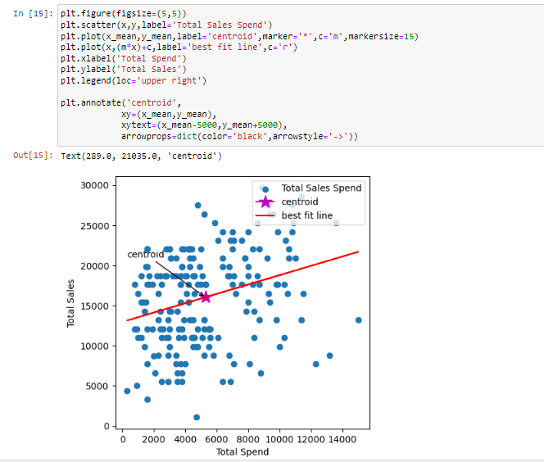

**6. Predict values based on the centroid**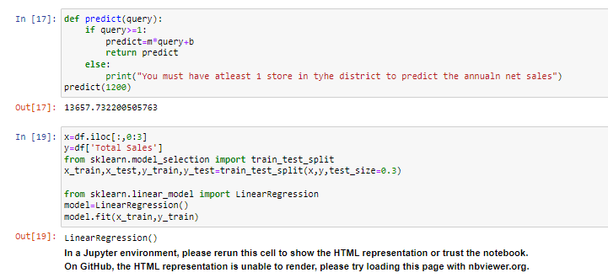

**6. Select features for training and testing**



**7. Perform Linear Regression**



**8. Predict the values**

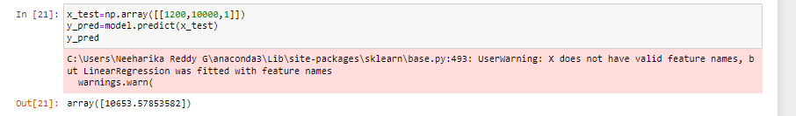

**SET - 4**

***Perform Naïve Bayes by creating synthetic dataset***

**1. Generate a classification dataset**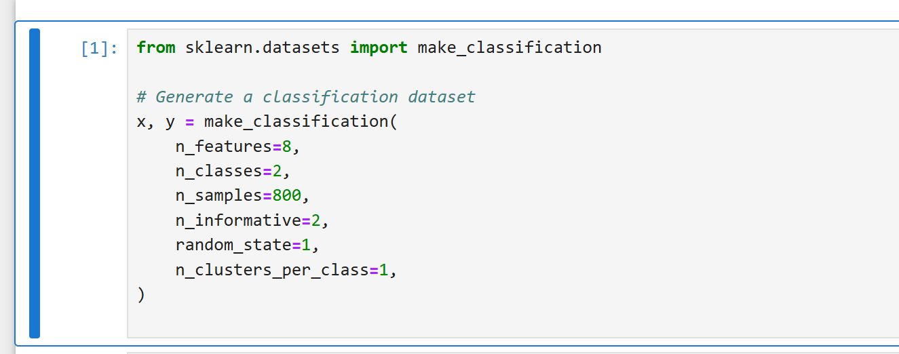

**2.Display a scatter plot**

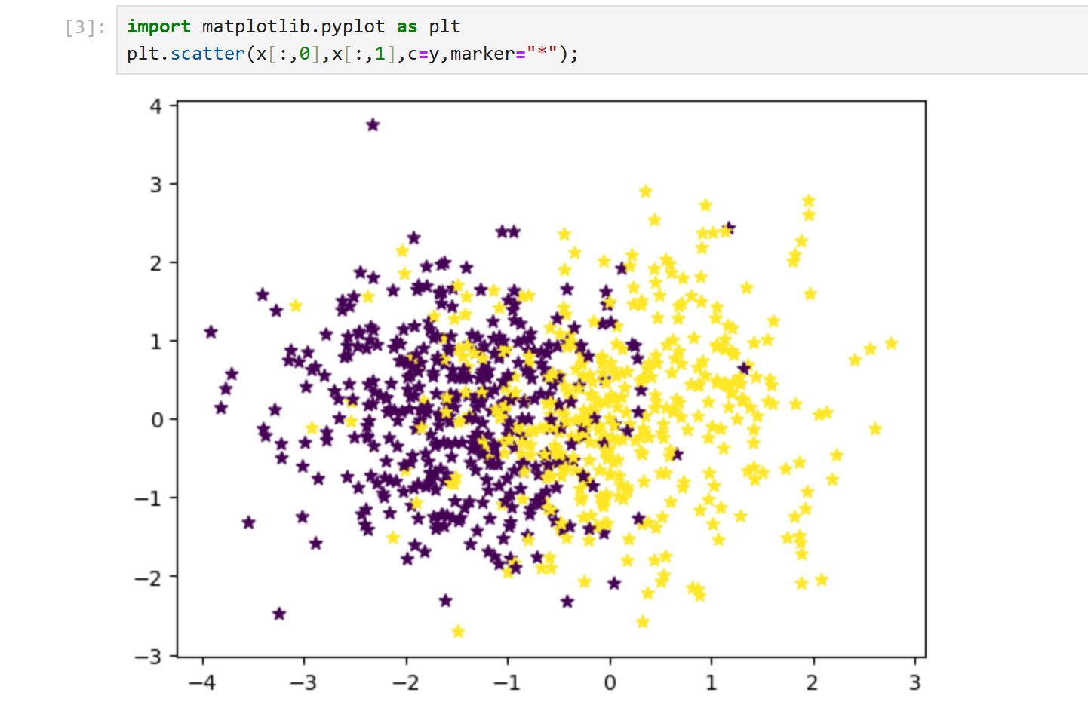

**3.Select features for training and testing**

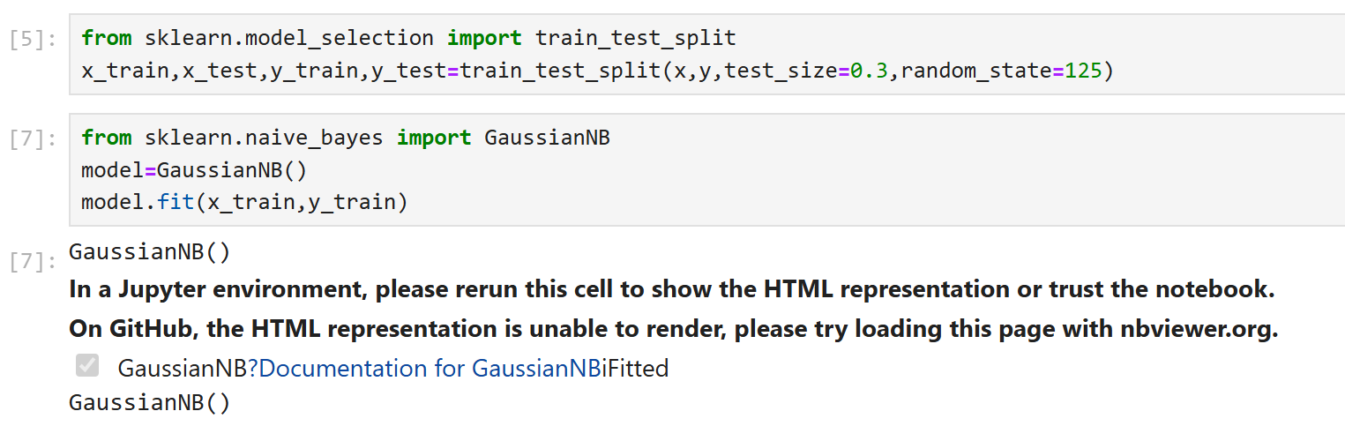

**4.Import the Naïve Bayes classifier**



**5.Print actual and predicted values**

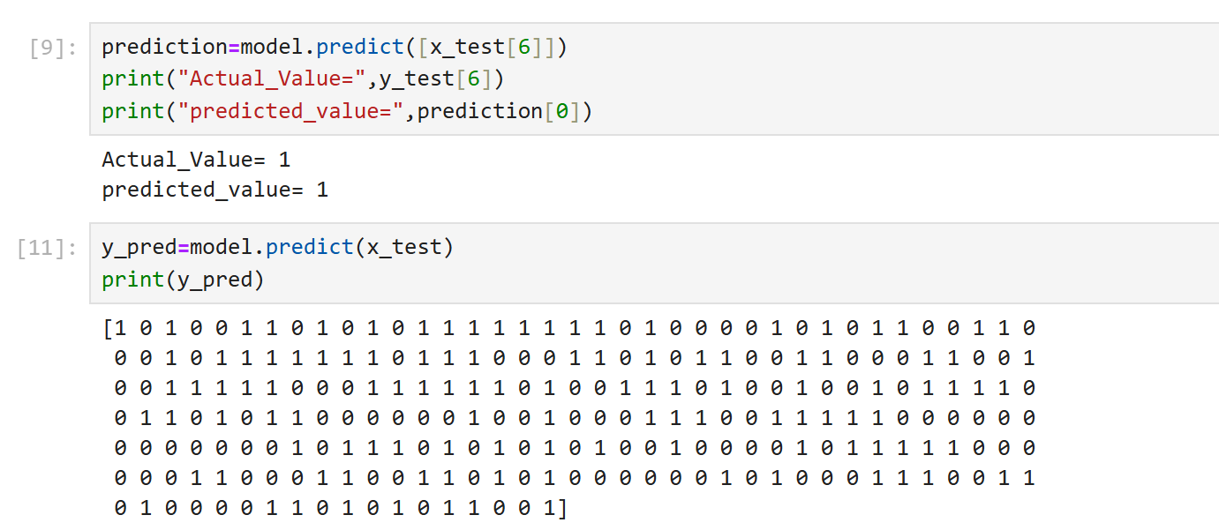

**6.Predicting the training data**



**7.** **Calculate the accuracy and F1 score**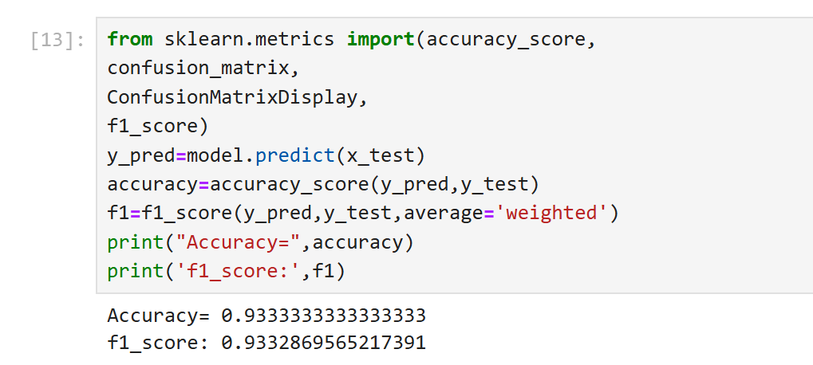

**8. Display the confusion matrix for predicted and actual values**

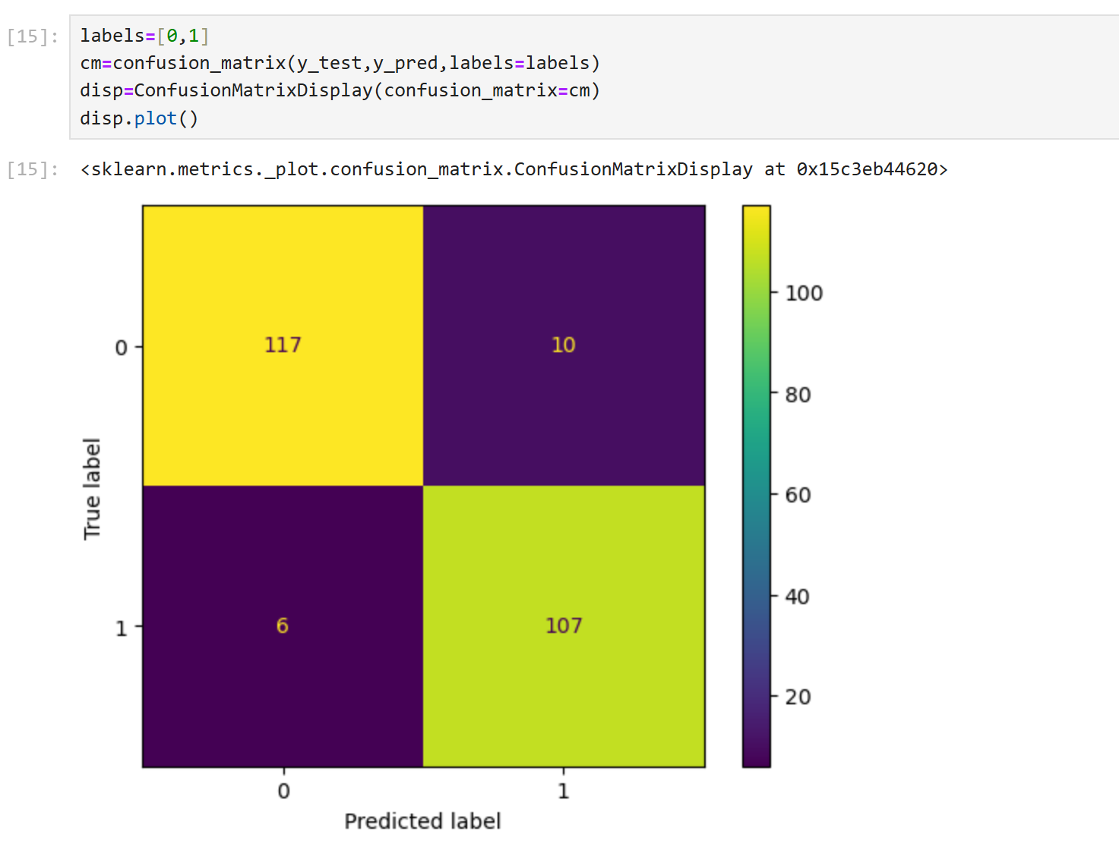

**SET - 5**

***Perform Linear Regression using advertising.csv***



**1. Read the Advertising dataset**

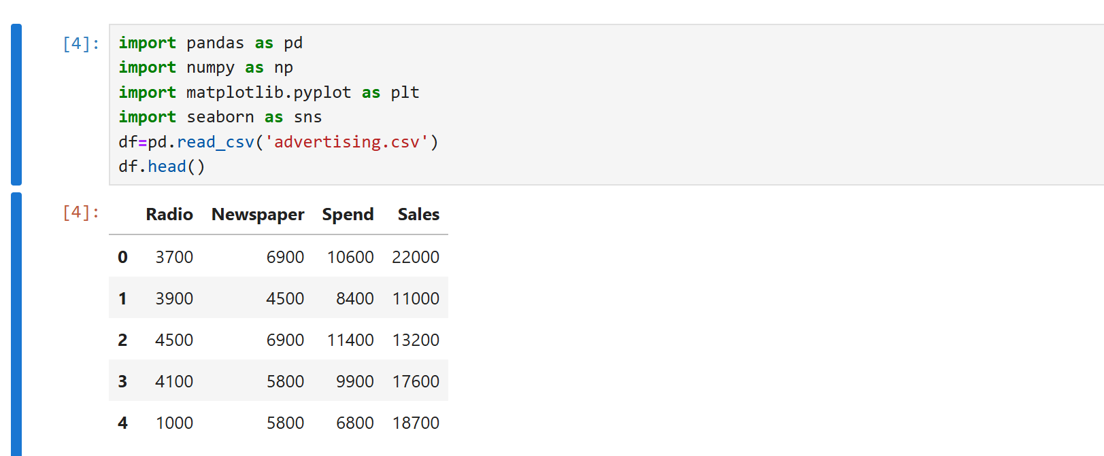

**2. Find the data type of the columns**

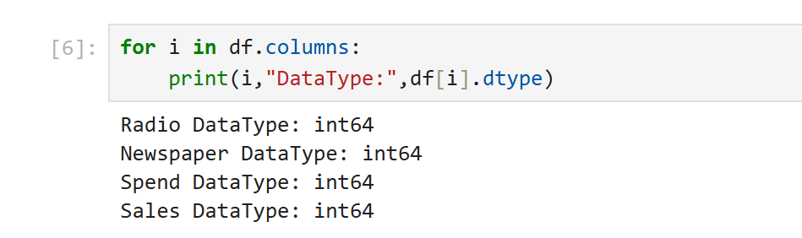

**3. Display the first 10 rows**

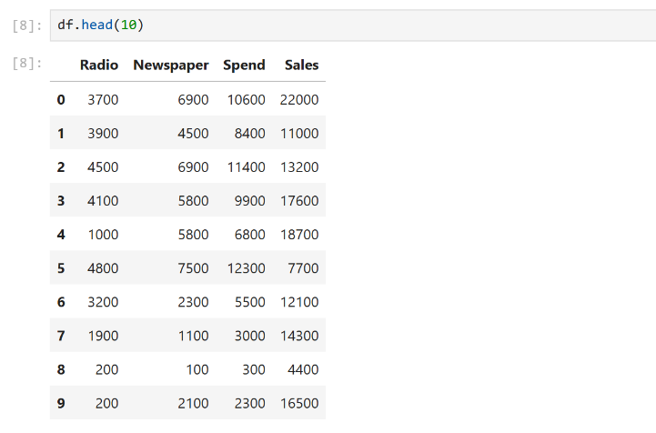

**4. Display a scatter plot for Radio and Sales**

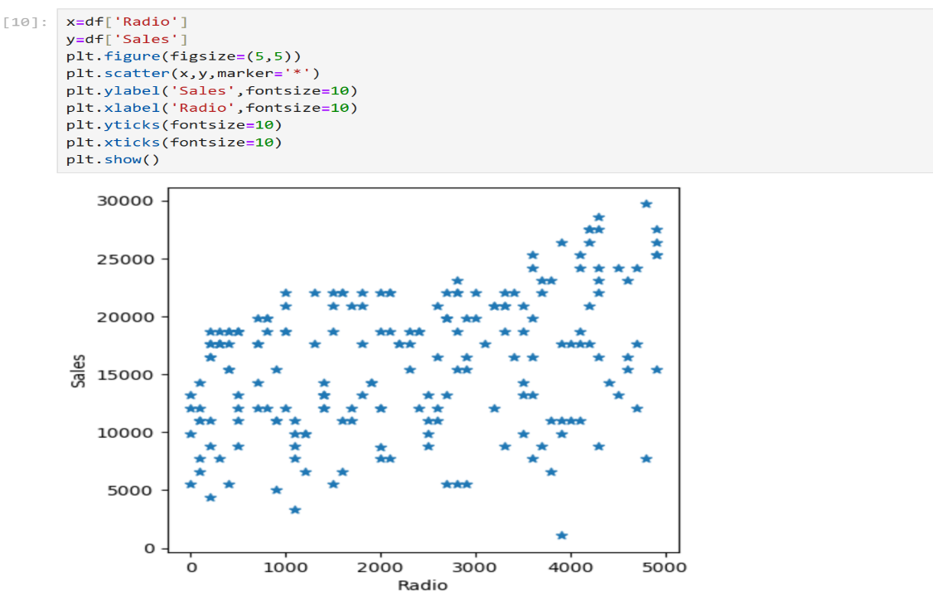

**5. Perform statistical analysis on the dataset**

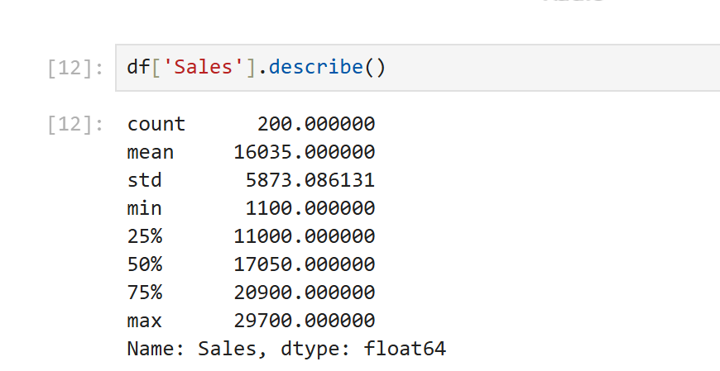

**5. Display a box plot for Sales**

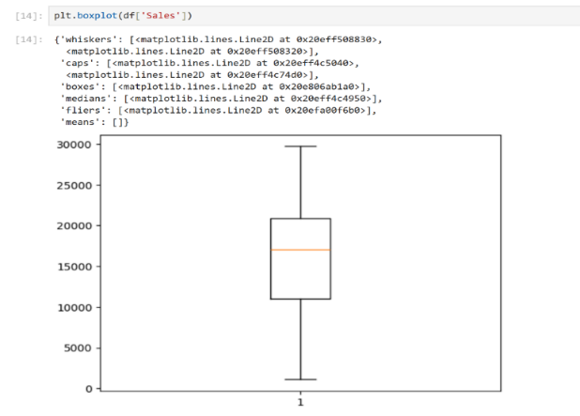

**6.Select features for training and testing**

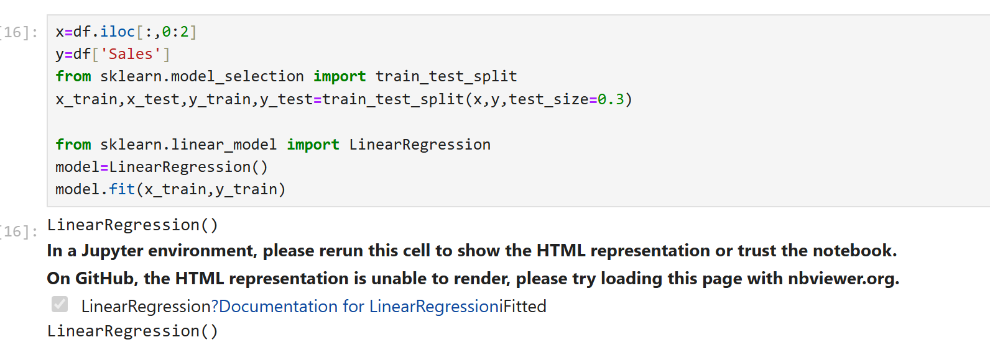

**7.Split data into 80% training and 20% testing using train_test_split**



**8.Import Linear Regression**



**9.Predicting the values**

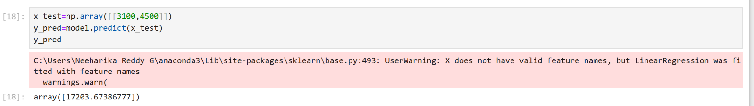

**10.Find coefficients**

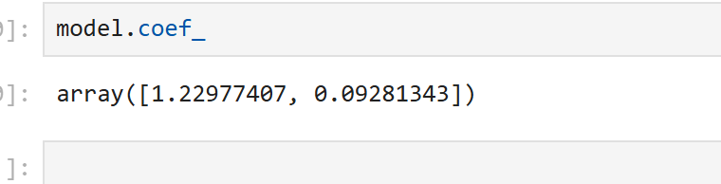

**SET - 6**

***Perform Linear Regression using insurance.csv***

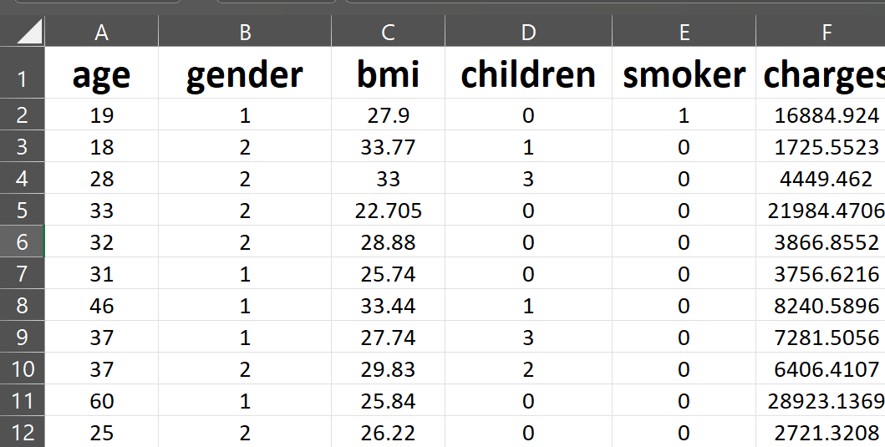

**1** **Read the Insurance dataset**

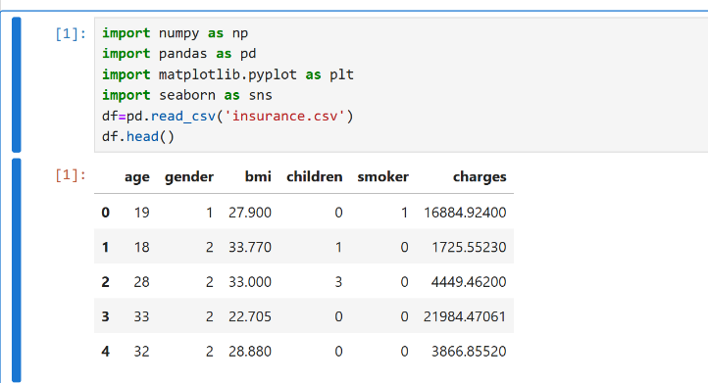

**2. Find the data type of the columns**

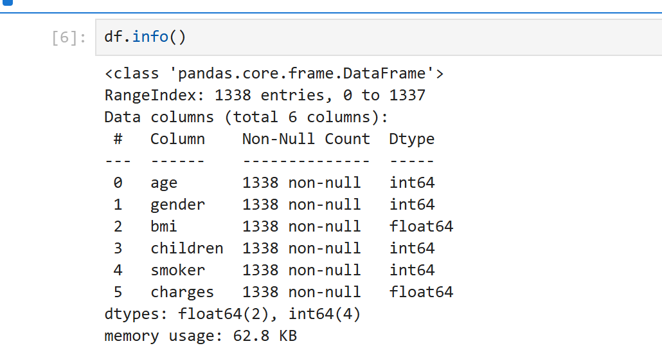

**3. Display the first 10 rows**

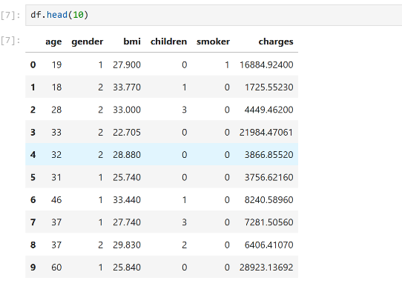

**4. Display a scatter plot for ‘BMI’ and ‘Charges’**

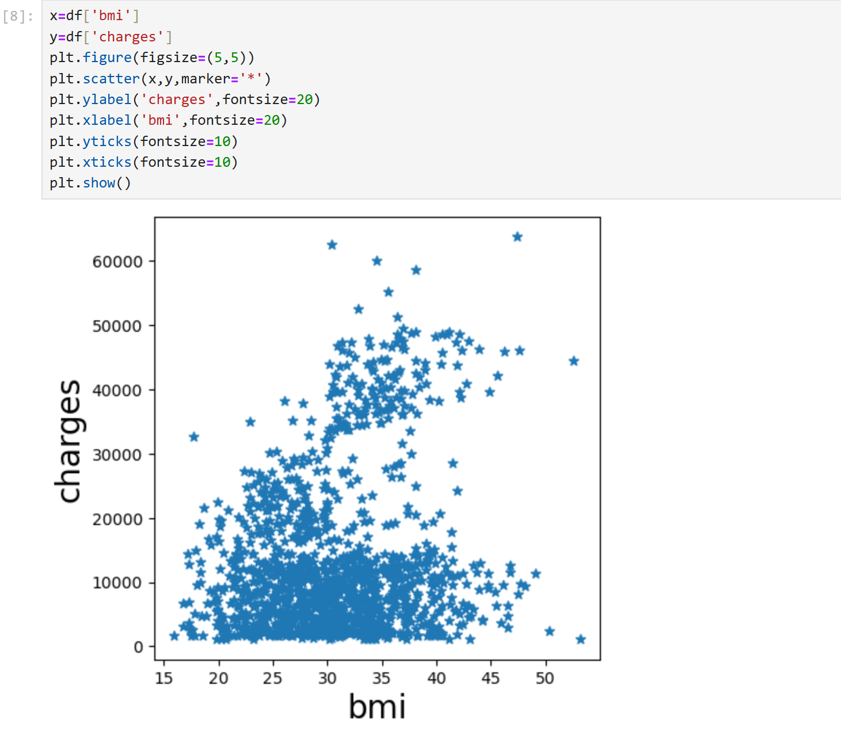

**5. Perform statistical analysis on the dataset**

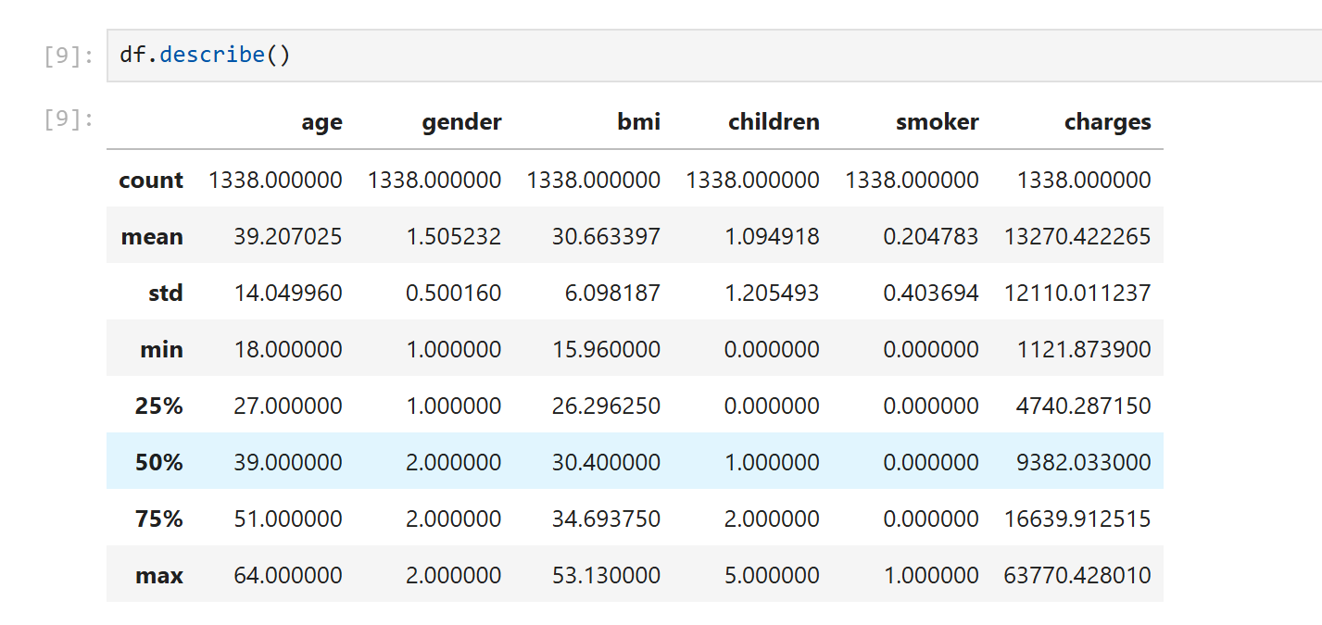

**5. Display a boxplot for ‘Charges’**

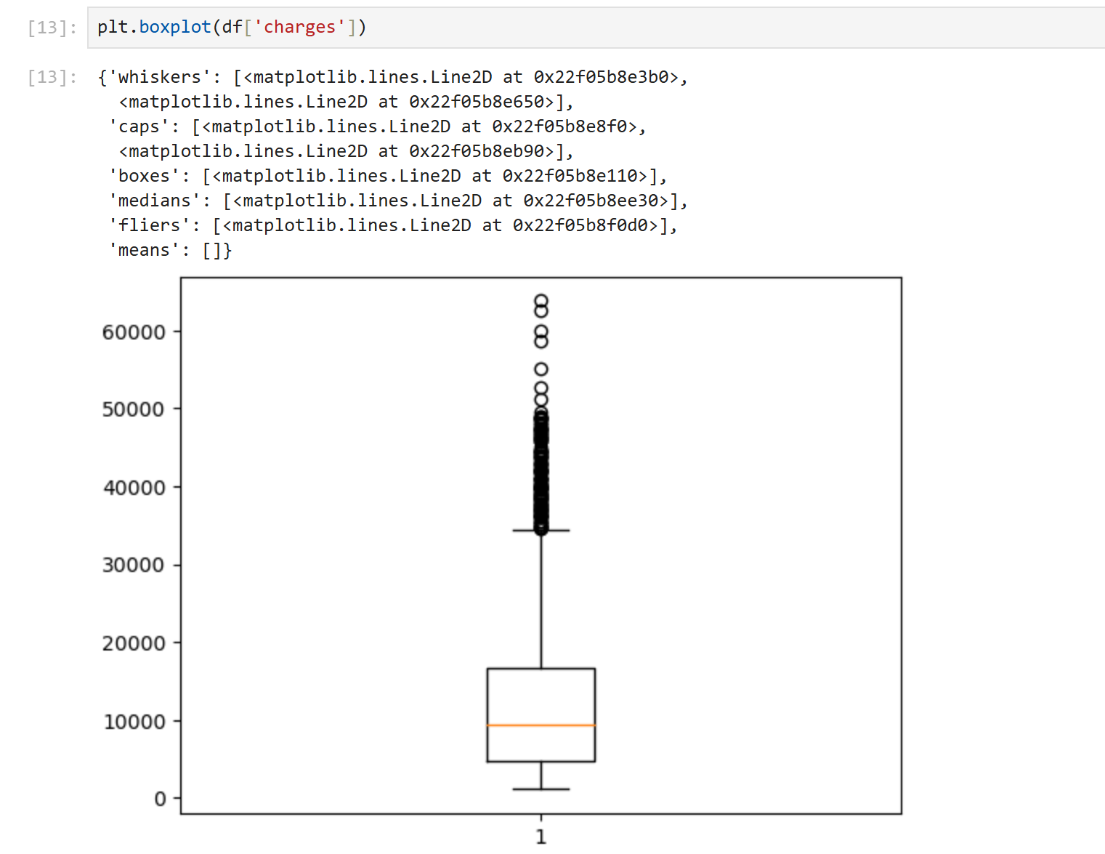

**6. Set independent features as [X]**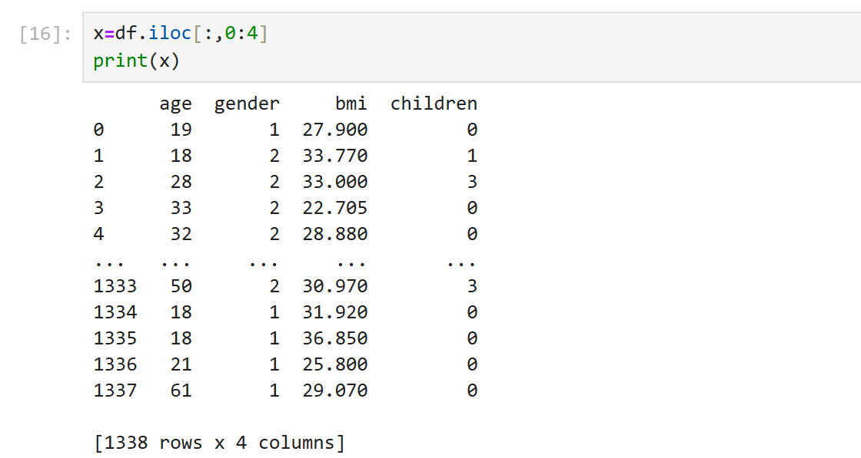

**7. Set dependent features as [Y]**

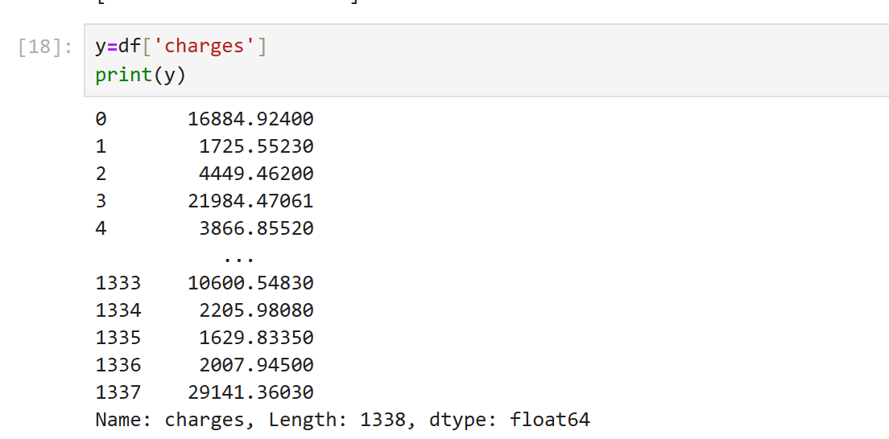

**8. Split data into 70% training and 30% testing using train_test_split**

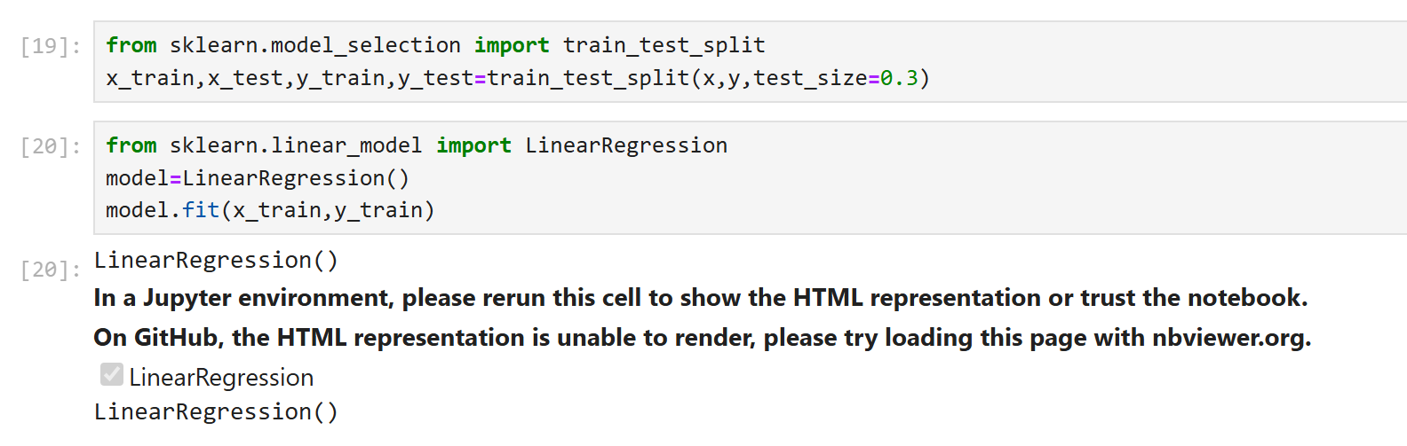

**9.Import Linear Regression**



**10.Predict the test data**

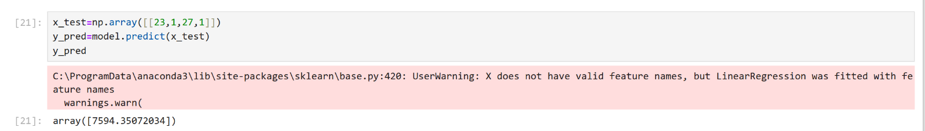

**11. Find the coefficients**

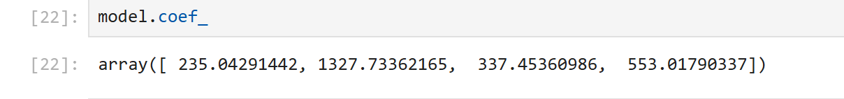

**SET - 7**

***Perform KNN classification using Iris.csv***

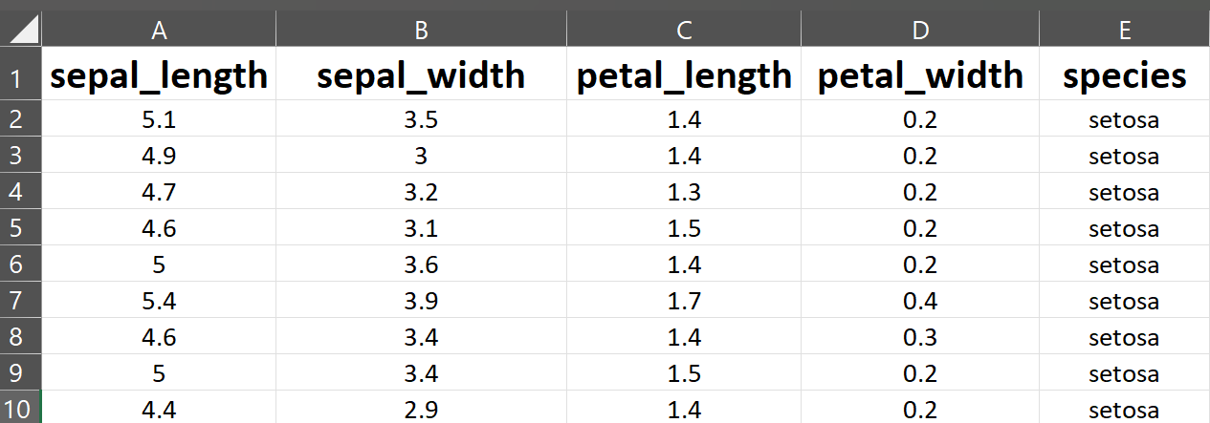

**1. Read the Iris dataset**

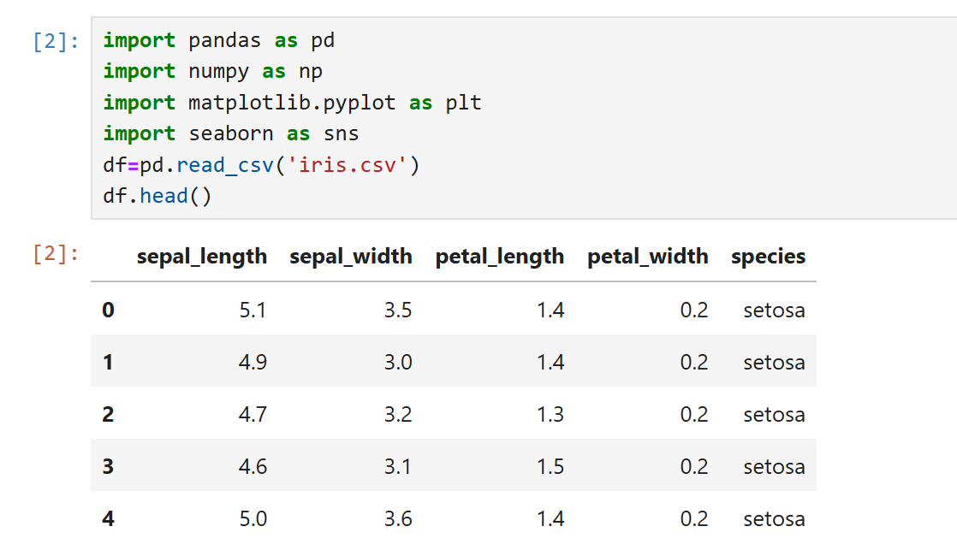

**2. Check for null values**

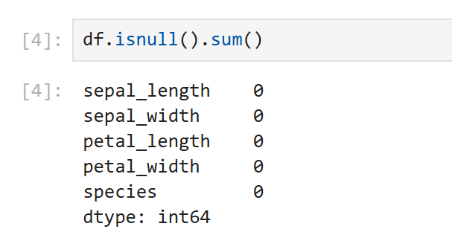

**3. Set independent features as [x]**

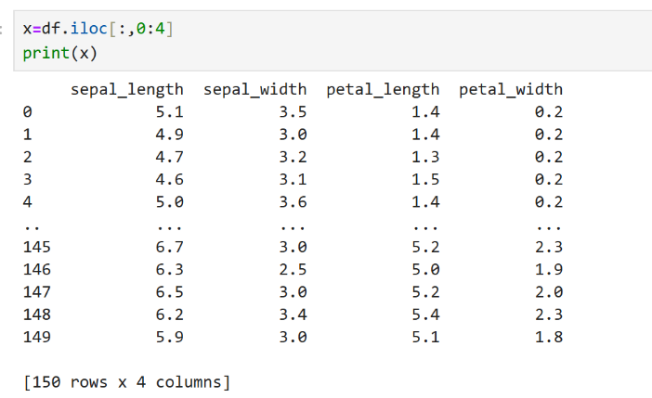

**4. Set target variable as [Y]**

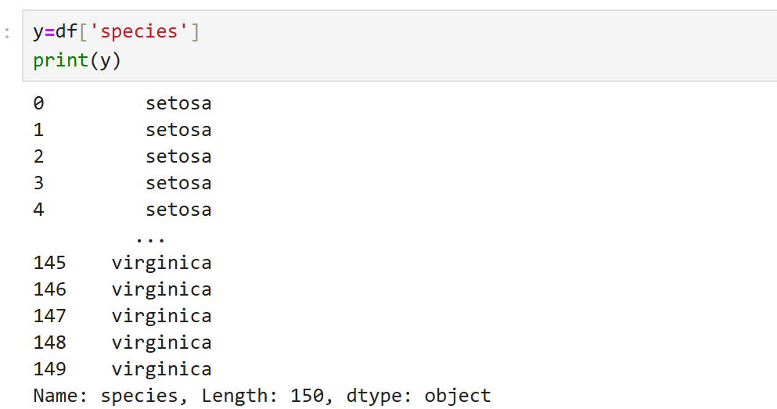

**4. Split data into 80% training and 20% testing using train_test_split**

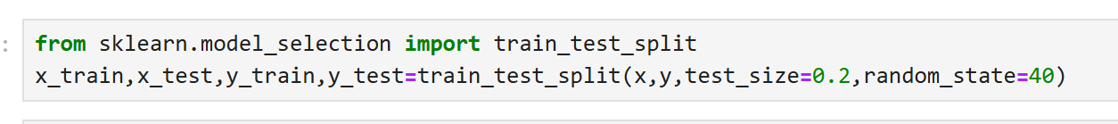

**5. Create and train a K-Nearest Neighbors (KNN) classifier with 7 neighbors using the Euclidean distance metric**

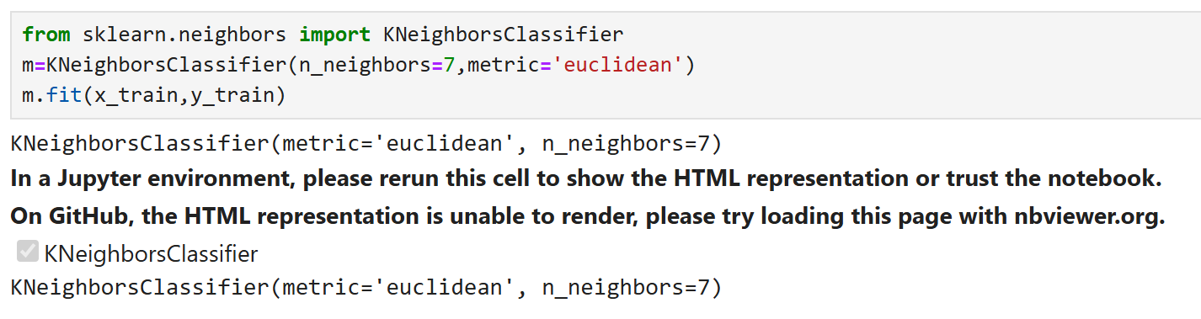

**6.Make predictions on the test data**

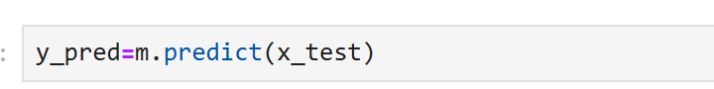

**7. Classification Report for Model Performance Evaluation**

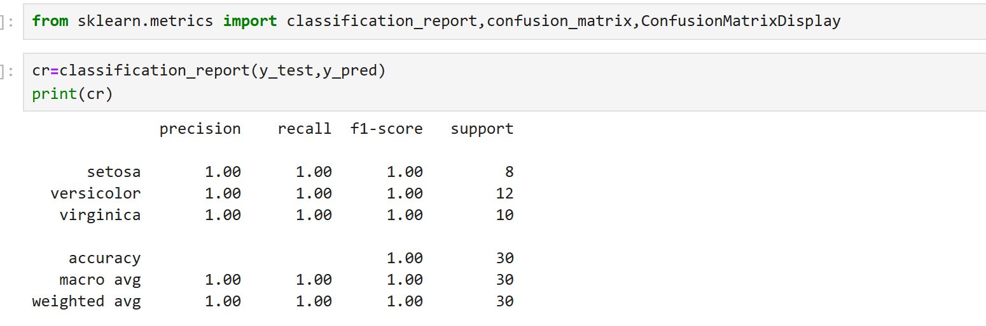

**8.Display Confusion Matrix for model results**

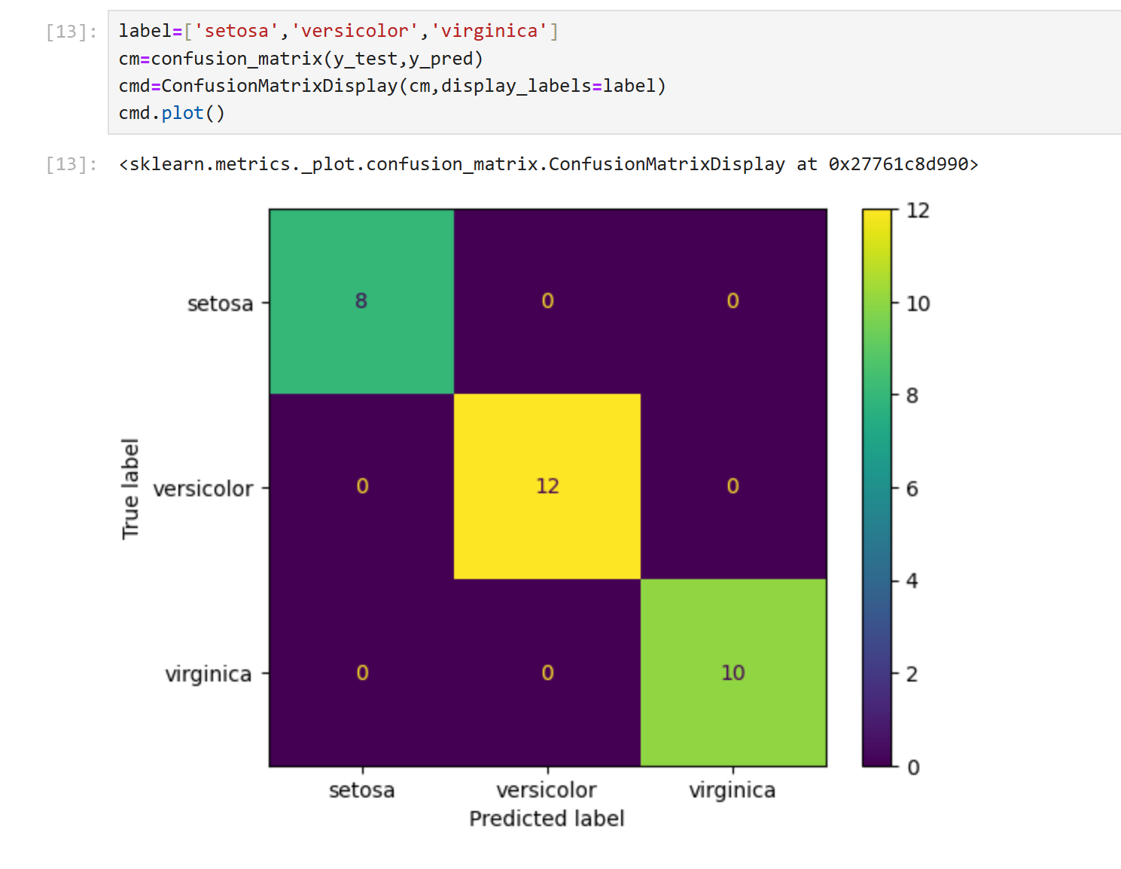

**SET - 8**

***Perform Find_S Algorithm***

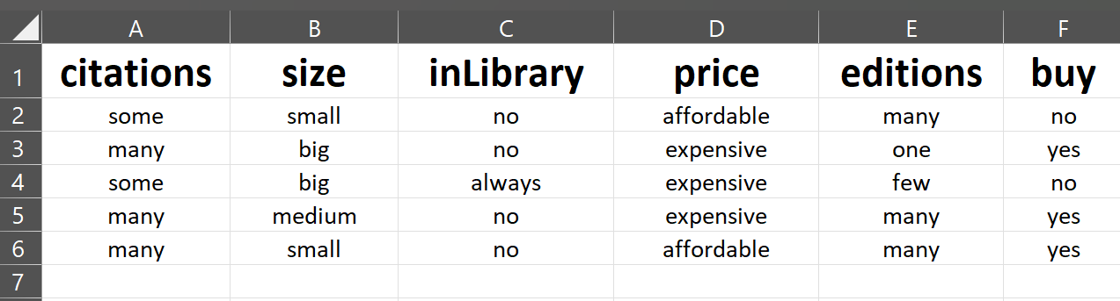

**1. Read the dataset**

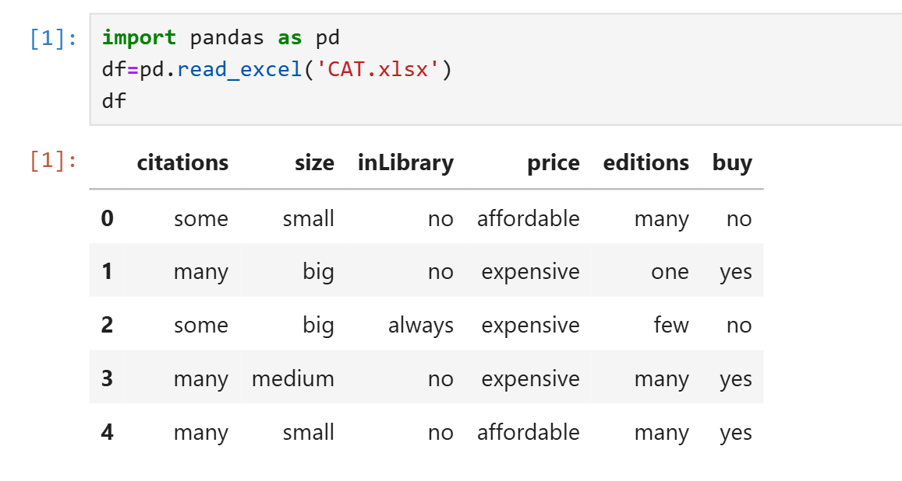

**2. Display Unique values**

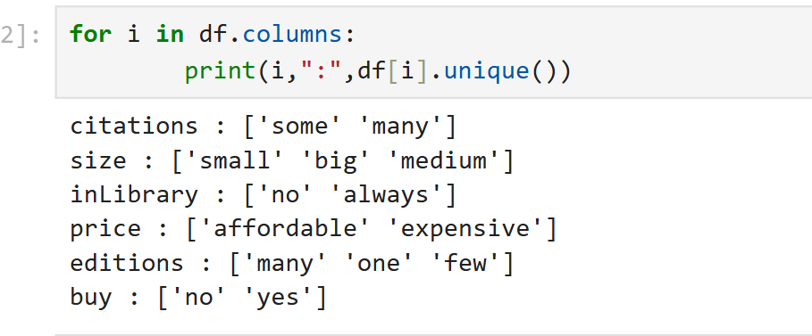

**3. Set the target variable as 'buy'**

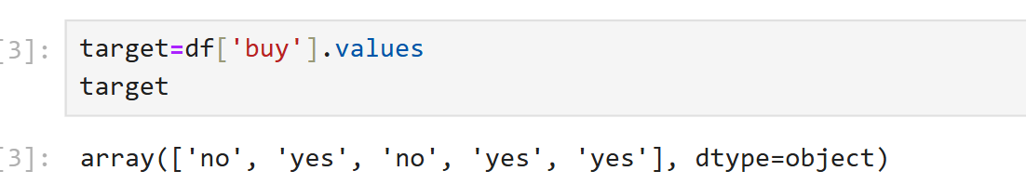

**4. Set all other variables as concepts (features)**

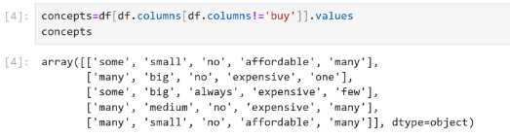

**5. Initialize the hypothesis as ‘0’**

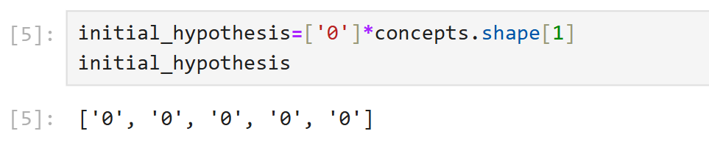

**6. Implement the Find-S Algorithm for ‘buy’ values**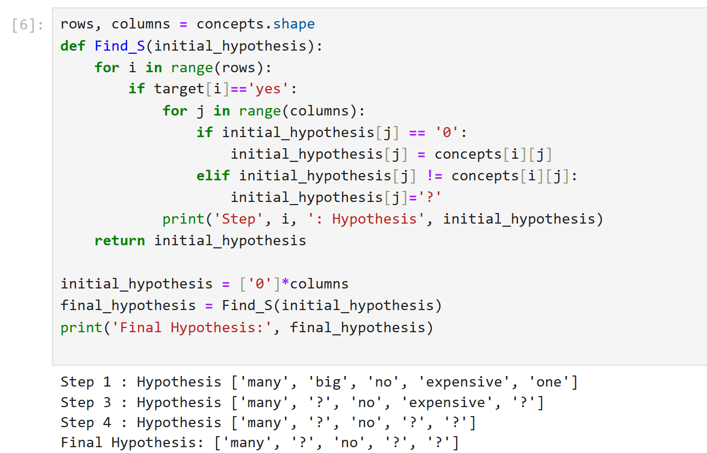

**7. Implement the Find-S Algorithm for ‘non-buy’ values**

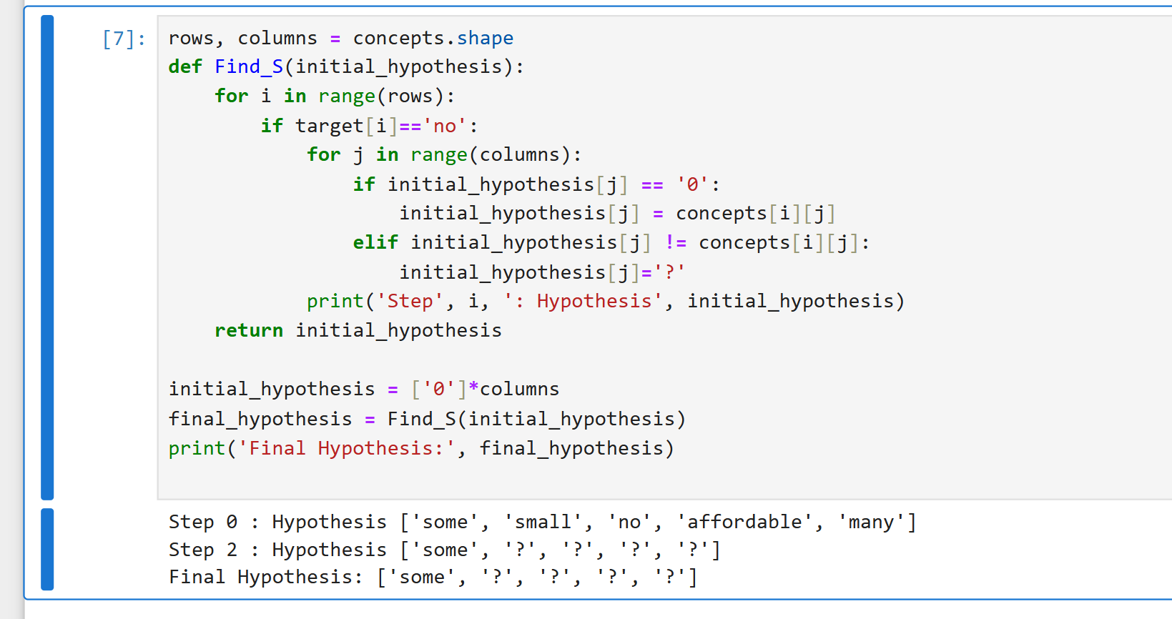

**LAB TEST – 2**

***Perform Clustering using fruits.csv***

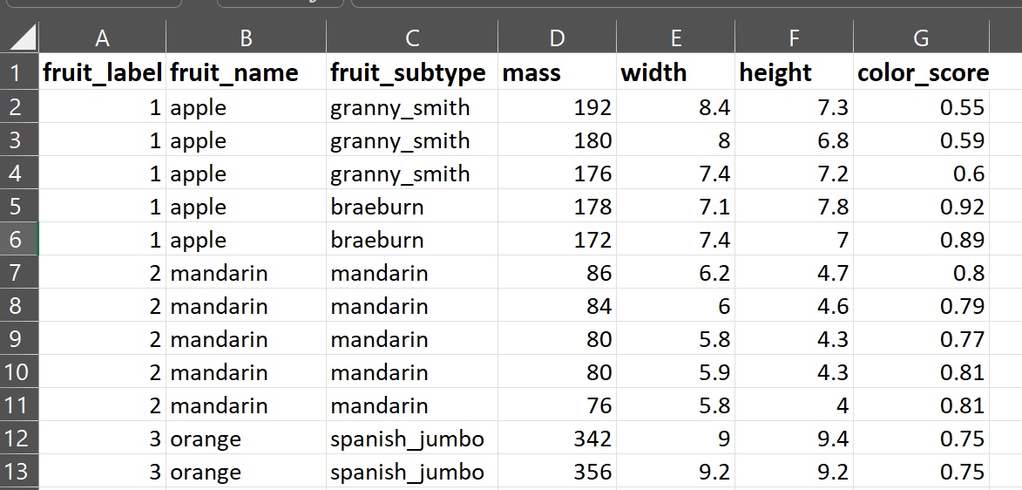

**1.Read dataset and visualize the mass and width features using scatterplot.**

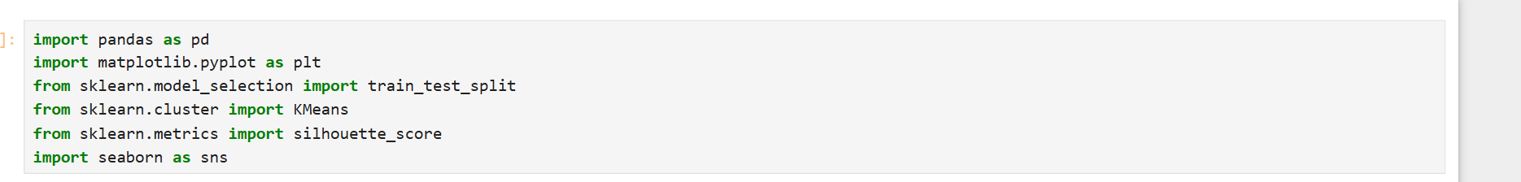

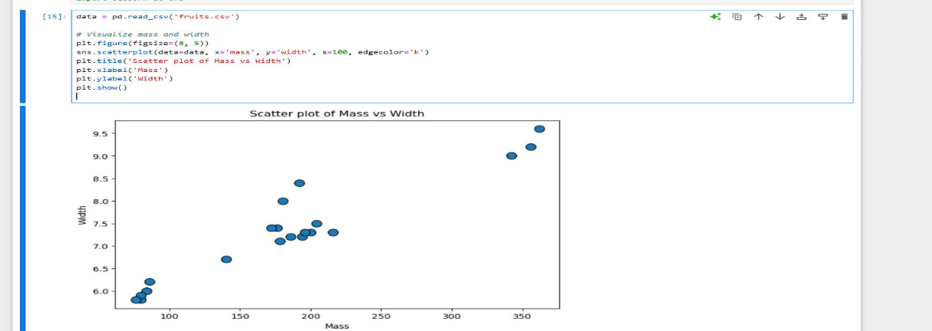

**2.** **Setup the training and test splits.**



**3.** **Find the optimal number of clusters for given data for different *k* values.**

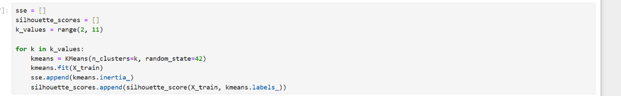

**4.Plot the performance score to choose optimal *k*.**

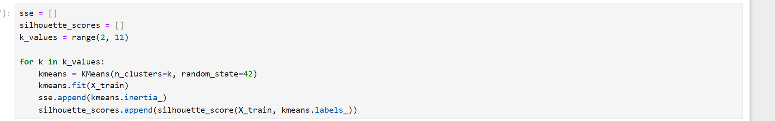

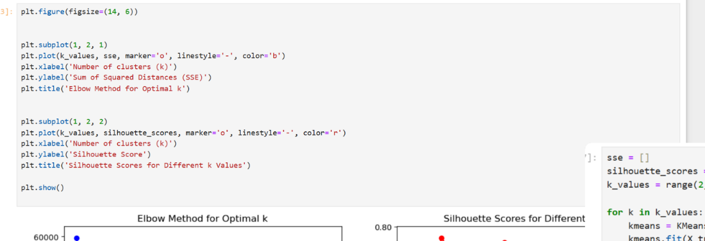

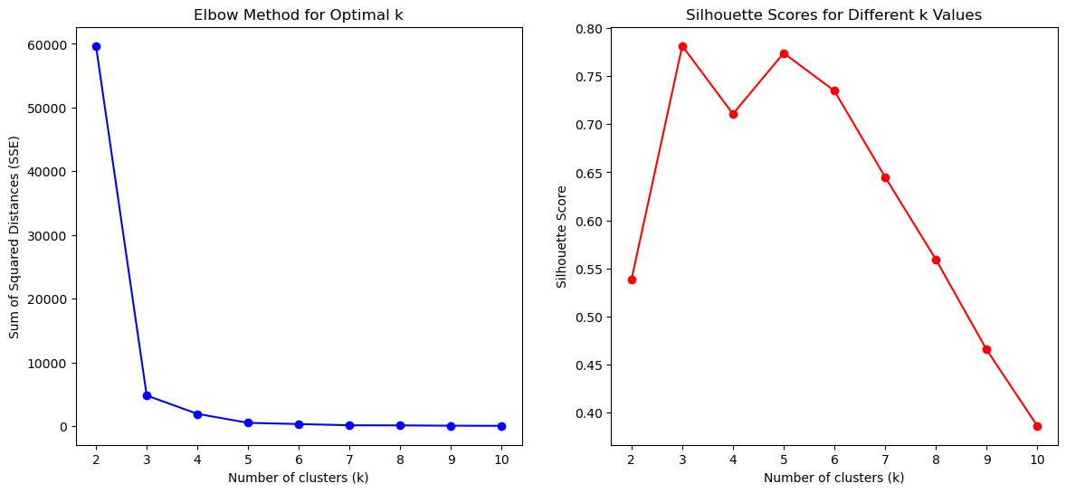

**5.** **Build the model with optimal *k*.**

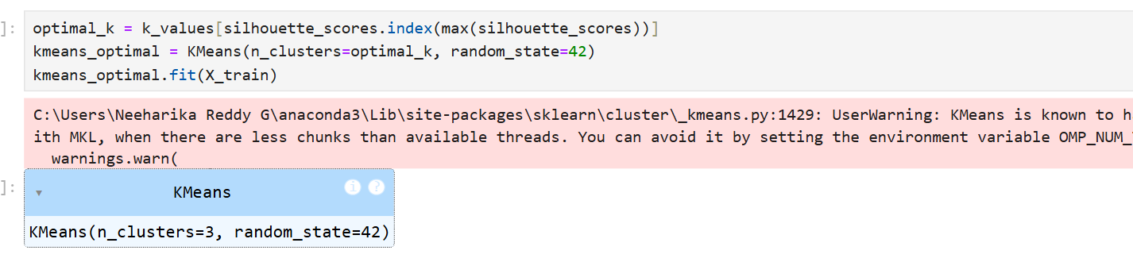

**6.Generate the visualization of *k* clusters**

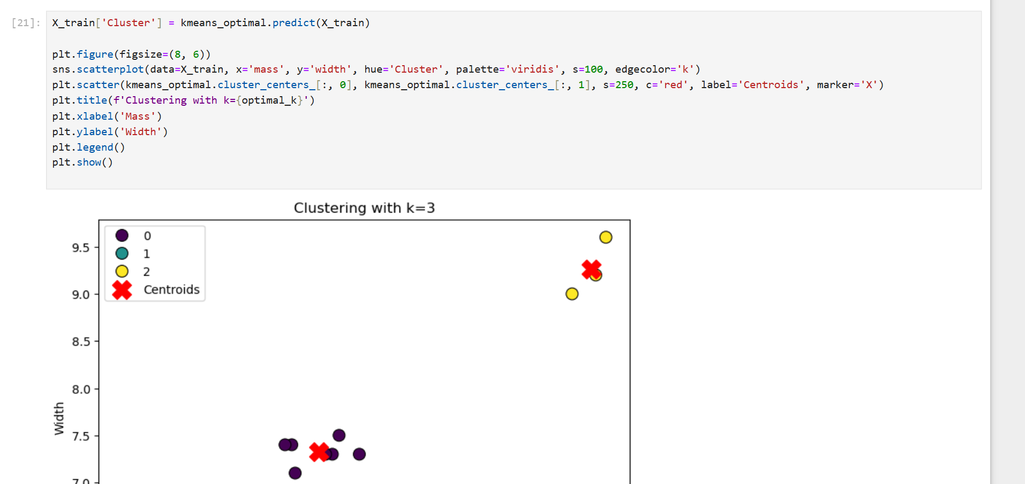

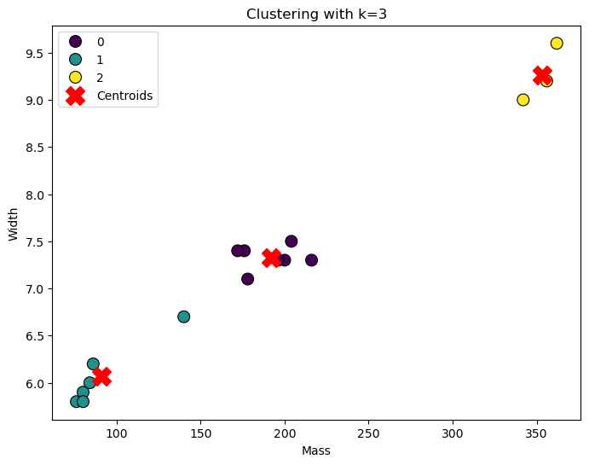

***Perform classification for the given dataset heart.csv***

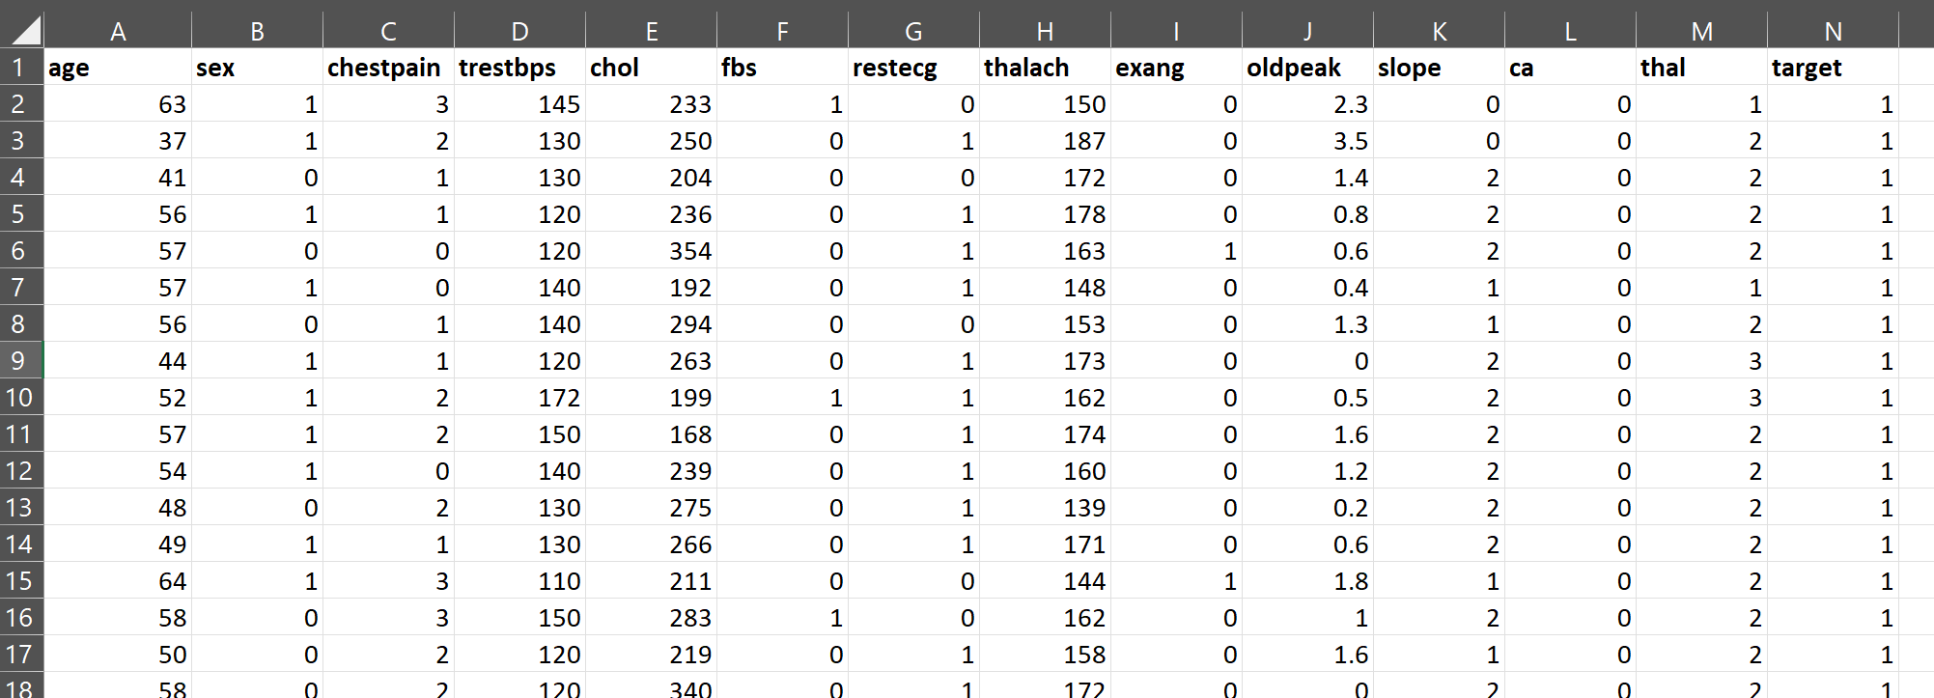

**1.** **Load the dataset and check for null values.**

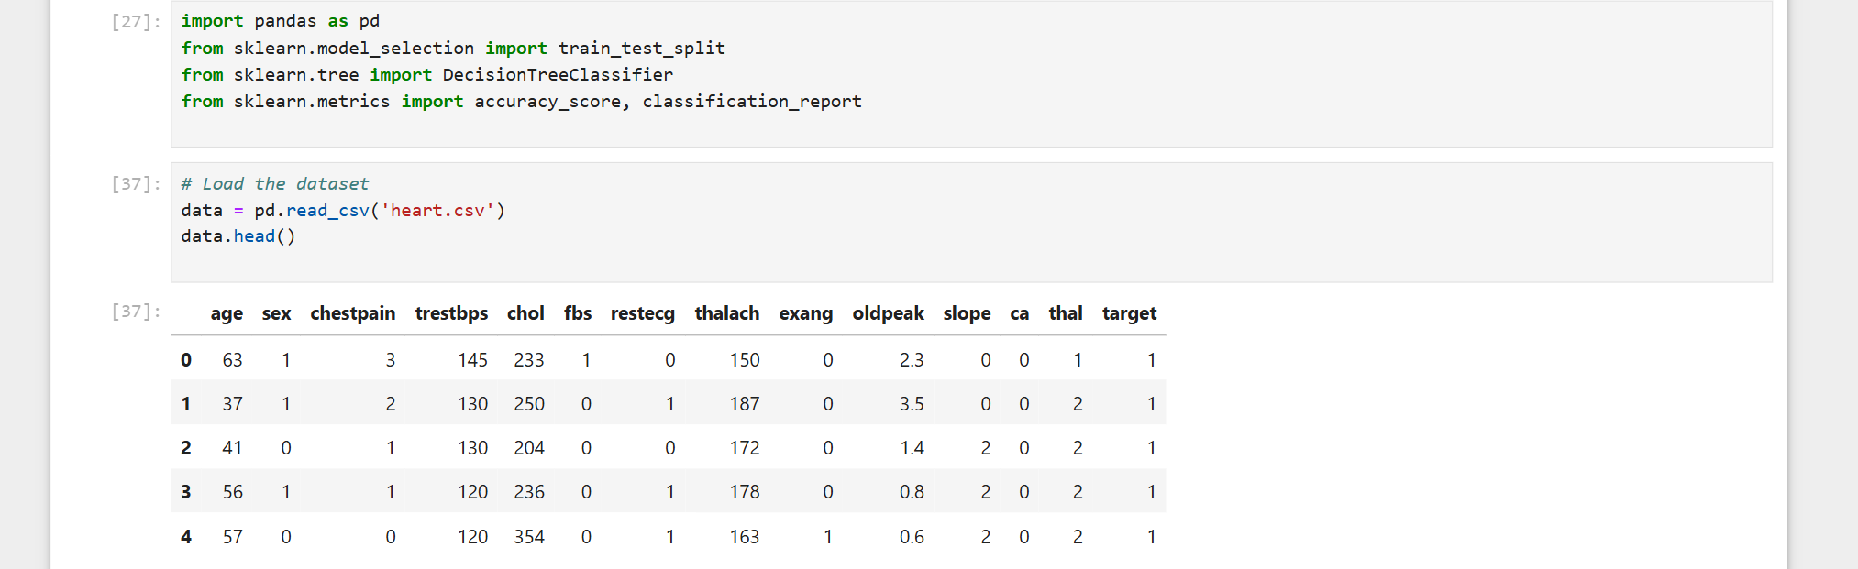

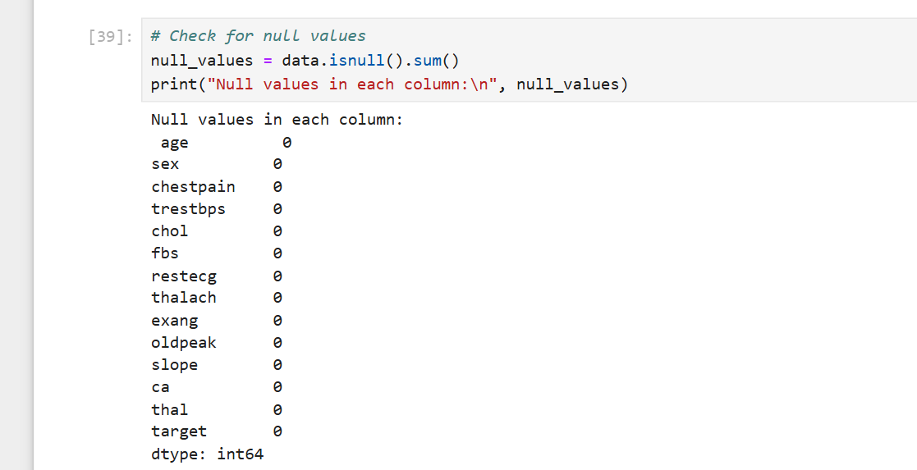

**2.** **Select the features and target variable.**



**3.Split the test set and train set ratio of 75:25**



**4.** **Build the model with DT classifier.**

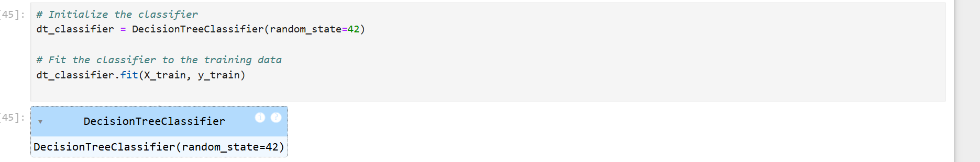

**5.** **Predict the drug class for test set.**

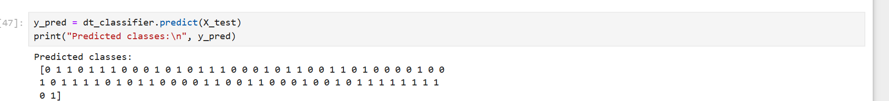

**6.Generate model accuracy and classification report.**

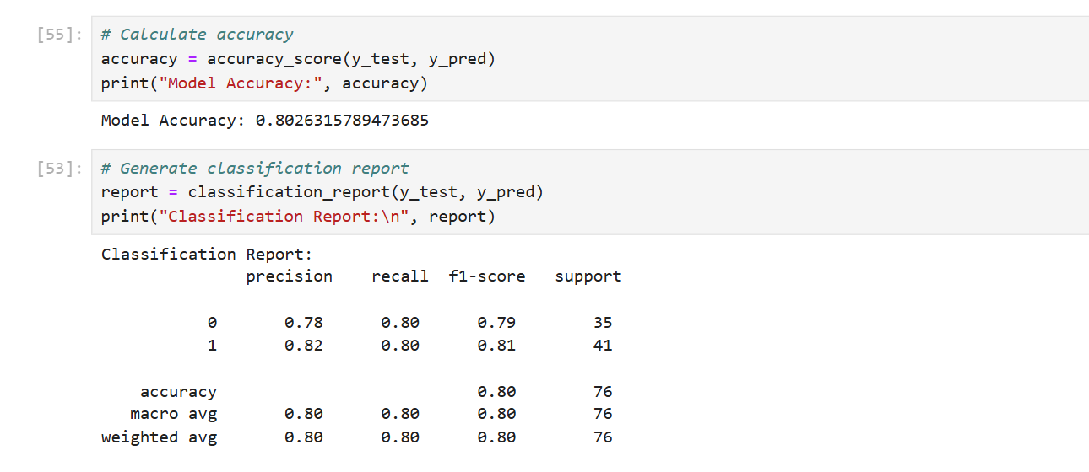

***Perform drug Classification for the given dataset drug.csv***

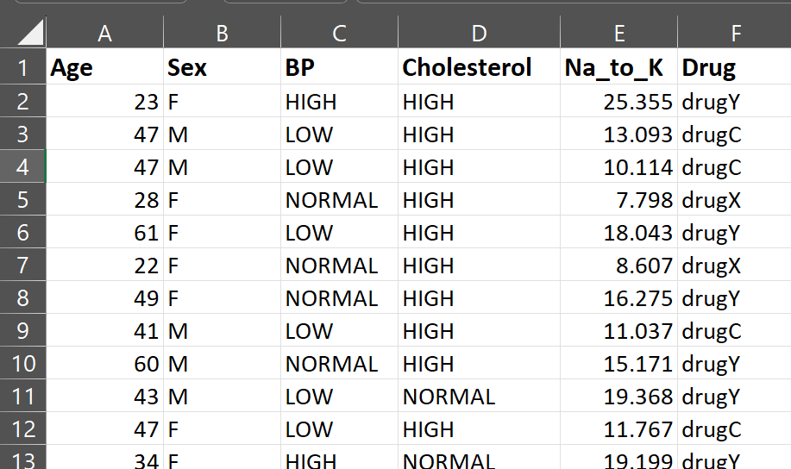

**1.Load the dataset and check for null values.**

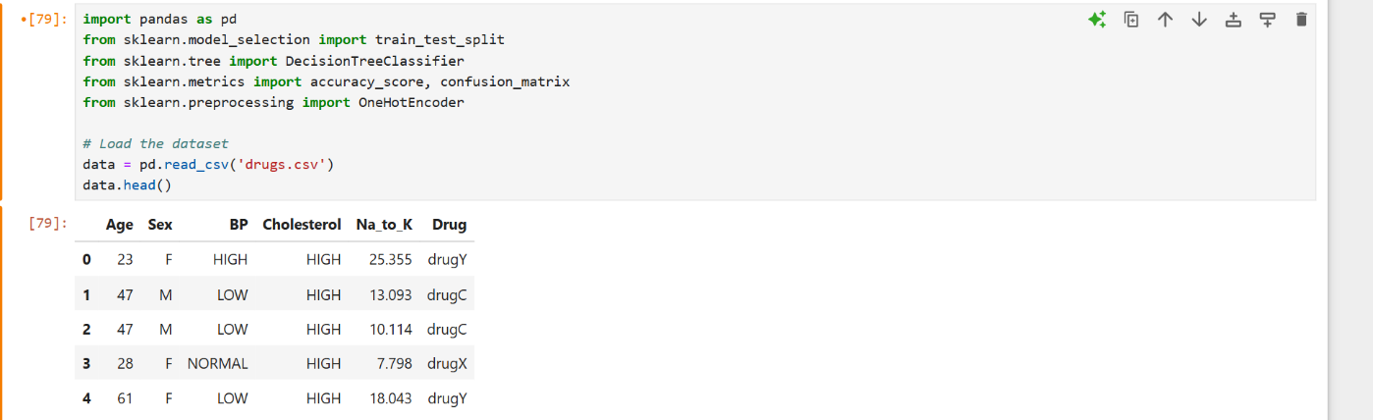

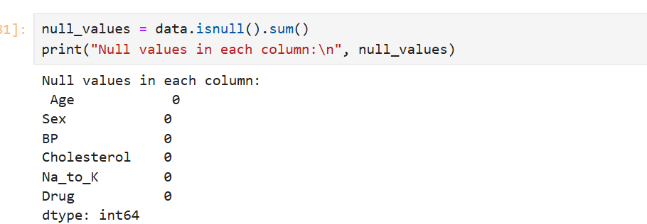

**2.** **Select the features and target variable.**



**3.** **Split the test set and train set ratio of 70:30**



**4.** **Create and Train the DT classifier.**

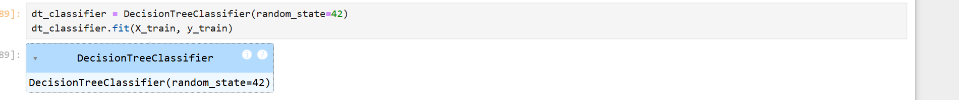

**5.** **Predict the drug class for test set.**

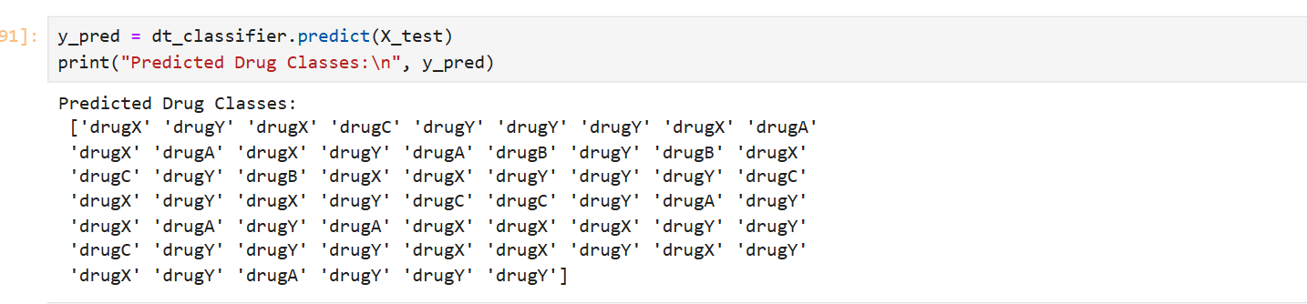

**6.Generate model accuracy and confusion matrix.**

